Monthly US residential energy consumption

Class Prep

Data

Evidence of correct data

Tail (energy)

MSN YYYYMM Value Column_Order Description Unit

1228 TERCBUS 201801 2704.493 2 Total Energy Consumed by the Residential Sector Trillion Btu

1229 TERCBUS 201802 1965.771 2 Total Energy Consumed by the Residential Sector Trillion Btu

1230 TERCBUS 201803 1896.218 2 Total Energy Consumed by the Residential Sector Trillion Btu

1231 TERCBUS 201804 1542.179 2 Total Energy Consumed by the Residential Sector Trillion Btu

1232 TERCBUS 201805 1378.514 2 Total Energy Consumed by the Residential Sector Trillion Btu

1233 TERCBUS 201806 1562.457 2 Total Energy Consumed by the Residential Sector Trillion Btu

1234 TERCBUS 201807 1782.894 2 Total Energy Consumed by the Residential Sector Trillion Btu

1235 TERCBUS 201808 1729.648 2 Total Energy Consumed by the Residential Sector Trillion Btu

1236 TERCBUS 201809 1488.834 2 Total Energy Consumed by the Residential Sector Trillion Btu

EDA

Time Series plot of Monthly US residential energy consumption

(in trillion Btu)

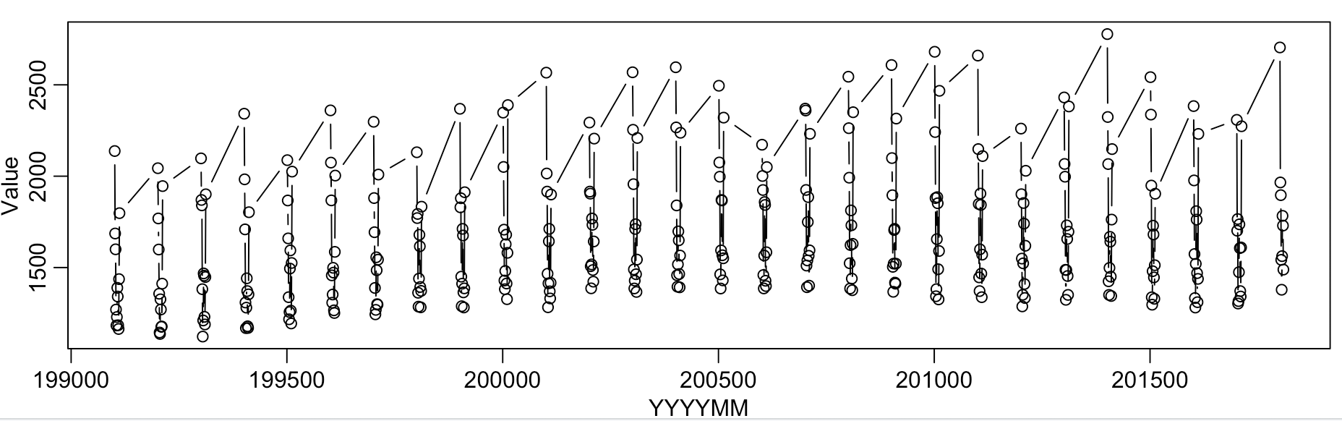

Conclusion: It does appear a monthly pattern. It could be caused by the usage of utilities during winter time.